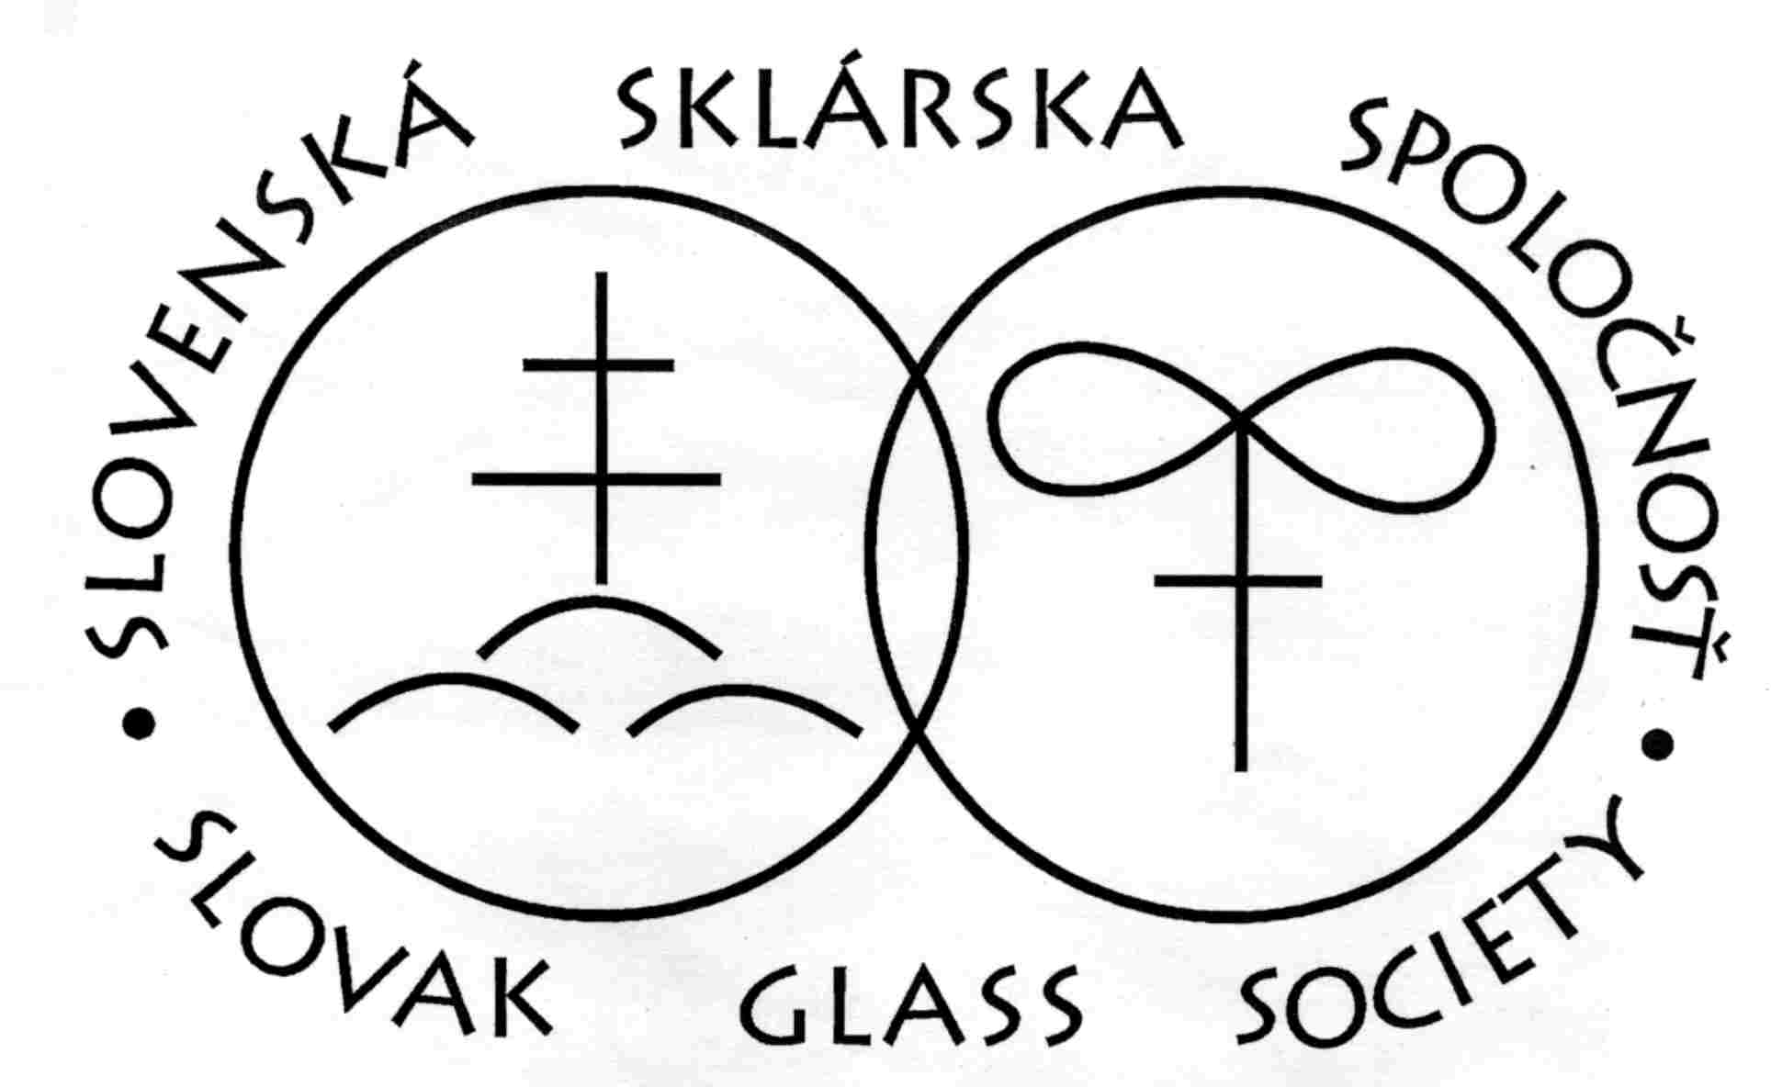 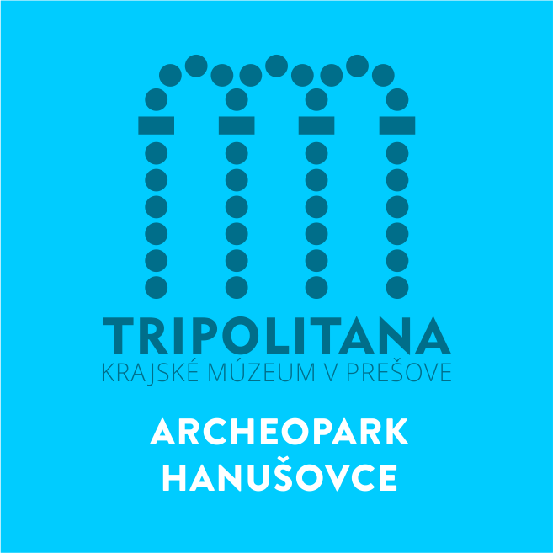 SOŠS

Slovak Archeological Society´s Commission for Support of Historical Glass Interdisciplinary Research in Slovakia, of the Slovak Academy of Sciences, in cooperation with the Slovak Glass Society, Regional Museum in Prešov-Manor House and Archeopark Hanušovce nad Topľou, Fun Glass University of Trenčín and High school of Glass Lednické Rovne are organising Second Interdisciplinary Round table, Workshop and Experiments

History of Glass - East Slovakia
21th – 23th June 2019

Location:
Manor House and Archaeopark (Kaštieľ a archeopark)
Hanušovce nad Topľou (contact person Samuel Bruss)
Region Prešov (East Slovakia)
The map: www.museum.sk/kastiel-a-archeopark-hanusovce-nad-toplou-tripolitana.html

Round table: Traditionally dedicated to various areas of life, science and research connected with the history of glass especially in East Slovakia. The working languages are Slovak and Polish.
Workshop: Glass bead making techniques from glass furnace and glass lamp. Glass painting and stained glass production. The working languages are: Slovak, Polish, German and English.
Glass Experiments:
Melting of ash glass prepared on the basis of archaeological finds of historical glass from Slovakia. Results will be published.

Organisational committee:
D. Staššíková-Štukovská, L. Krokker, P. Šimurka, S. Bruss, A. Plško, P. Šimončičová Koóšová, A. Krupičková

Preliminary program:

21.06.2019 - Round table, workshop |  | 22.06.2019 - Glass experiments
8.00 - 9.00 h. | Registration of participants | 9.30 - 15.00 h.: | Experiments and production of glass jewelry in the furnace and lamp
9.00 -12.00 h: | Welcome speeches, scientific program – selected lectures on historical glass | 15.00 h.: | End of wood heating in a 9th century glass furnace in Archeopark
14.00 -18.00 h.:  18.30 - 00.00 h.: | Round table, posters and artefacts, workshop (glass beads and vitraje)  Workshop at glass furnace from 9th century and „glass party“ | Excursion to Trzinica 23.6.2019 | According to interest.

Contact: If you are interested to participate in the round table, let us know through the enclosed reply form before the 30th May 2019 together with a key words (no more than 10 words). Please consign it to: Dr. D. Staššíková-Štukovská (danica.stassikova@gmail.com).

Accomodation: Hanušovce nad Topľou, Reštaurácia Eden: http://www.edenubytovanie.sk; Reštaurácia Lietadlo (2 km near the Hanušovce nad Topľou): http://www.tajana.sk/lietadlo/restauracia; Prešov (23 km near the Hanušovce nad Topľou) – www.Trivago.sk

Fees: Travel, board, glass party and accommodation during the conference is to be payed individually. Registered participants will be informed about their inclusion into the conference program.

SOŠS

Binding Registration Form
to the 2nd Interdisciplinary Round Table, Workshop and Glass experiments – History of Glass,
East Slovakia „2019“

Name:
Surname:
Address:
Email contact:
The presentation title (with the specification: lecture, poster, glass artefacts). To join separately the key words in English or Slovak.

Interest in participating in glass melts and experiments on Saturday, June 22nd, 2019: yes no
Participation in the social evening on Friday, June 21th 2019: yes no
Interest in the excursion to Trzinica, Poland, on Sunday, June 23rd 2019 : yes no

................................... ..................................................
Date Signature

To be sent at the latest on 30th May 2019 to the address:

Danica Staššíková - danica.stassikova@gmail.com

Key words:

